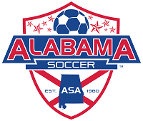PREVIOUS AWARD WINNERS 2017-2013

2017 Award Winners
Jeremiah Massa – Competitive Coach of the Year (Girls)
Carlo Schiavoni – Competitive Coach of the Year (Boys)
John Brandon – Recreation Coach of the Year (Girls)
Bryan Tharp – Recreation Coach of the Year (Boys)
Joe Mullins – Administrator of the Year
David Puckett – Volunteer of the Year

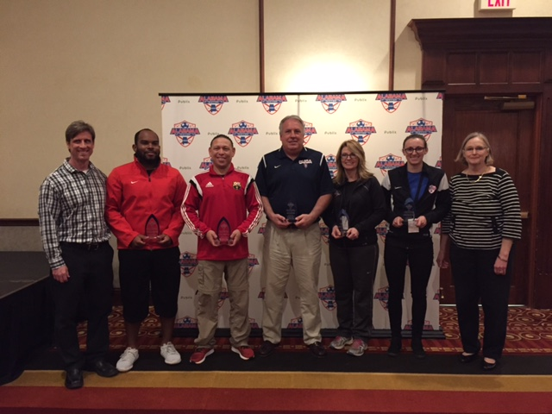
2016 Award Winners
Jay Hammond – Competitive Coach of the Year (Girls)
Luke Whittle – Competitive Coach of the Year (Boys)
Emma Greenwood – Recreation Coach of the Year (Girls)
Jim Jeter – Recreation Coach of the Year (Boys)
Christie Clark – Administrator of the Year
Sarah Grace Jones – TOPSoccer Buddy of the Year
Katie Steinert – TOPSoccer Coach of the Year

2015 Award Winners
Mindy McBride - Competitive Coach of the Year (Girls)
Oleg Sinelnikov - Competitive Coach of the Year (Boys)
Chad Parish - Recreational Coach of the Year
Brian Foy - Publix Volunteer of the Year
Matthew Stewart - TOPS Buddy of the Year
Michael Taylor - TOPS Coach of the Year

2014 Award Winners
Michael Latty - Competitive Coach of the Year (Girls)
Chad Harrelson - Competitive Coach of the Year (Boys)
Hugh Lee - Administrator of the Year
Frank Hernandez - Publix Volunteer of the Year
Taylor Smith - TOPS Buddy of the Year
2013 Award Winners
Mateo Peral - Competitive Coach of the Year (Girls)
Joel Wallace - Competitive Coach of the Year (Boys)
Calvin Fletcher - Recreational Coach of the Year
Pamela Dean - Administrator of the Year
Donna Mosholder - Publix Volunteer of the Year
Shawn Marlow - TOPS Buddy of the Year

