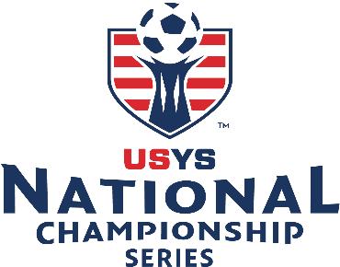

**COMMITMENT TO PARTICIPATE**

**2025 US Youth Soccer Southern Regional Championships Baton Rouge, LA | 2025 US Youth Soccer Southern Presidents Cup – Plano, TX**

[**https://www.usyouthsoccer.org/national-championship-series/**](https://www.usyouthsoccer.org/national-championship-series/)

<https://www.usyouthsoccer.org/south/presidents-cup/>

Our team agrees to represent Alabama Soccer Association should our team qualify to attend the 2025 US Youth Soccer National Championship Series (June 26 – July 2) or the Southern Presidents Cup (June 12 – June 16) event as either the State Champion or the Finalist. We agree to a non-refundable deposit of $225 to reserve our spot for 2025 summer events once the team is approved and it will be charged to the team’s club account and must be paid before any teams registering in the club for the spring 2025.

Our team agrees to comply with all requirements of our State, Region, and US Youth Soccer National Championship Series and Presidents Cup during the preparations for the event, and while in attendance at the event. Our team realizes that if we agree to advance to either Series and withdraw, Alabama Soccer Association and US Youth Soccer will issue fines and/or sanctions. Any fines and/or sanctions will be issued against your State Association. They will jeopardize the State Association by not being allowed to participate in any US Youth Soccer events in the future. As such, **we accept that any such fines and/or sanctions will be the team's responsibility.**

**NCS will combine the 18/19U age groups. PC will not be combined as of Oct 2024 -it may be combined later due to registration numbers.**

**Team Age/Gender: 13U 14U 15U 16U 17U 18U 19U ⃝ Boys ⃝ Girls**

**Team Club: _______________________________________________________**

**Team Name: ______________________________________________________**

**Coach Signature___________________________________________________**

**Printed Name of Coach_____________________________________________**

**Date: ____________________________________________________________**

**Email Address Coach: __________________________Cell Phone: ____________**

**Email Address Manager: _______________________ Cell Phone: ____________**

**⃝ YES - We will attend. Our team has been advised of the commitment to participate in this event and agreed to the non-refundable deposit of $225.**

**⃝ NO - Our team will NOT be attending either event**

**IMPORTANT: If our team does not finish in first place but an additional opening is available in our age group at the US Youth Soccer National Championship Series or US Youth Soccer Presidents Cup, we are prepared to accept the position upon notification and will fulfill all of the requirements as outlined above.**

**Coach Signature _________________________ Date__________________________**

**Printed Name of Coach ____________________________________**